**26 April 2019** **The Weekly Bulletin of Rotary Club of Kathmandu Mid-Town** **bc-27.4/019**

|  |
| --- |
| C:\Users\Public\Documents\RIP T1819_EN.png |

District: 3292 Web:www.rotarymidtown.org.np Club Id: 26776

**APRIL IS MATERNAL AND CHILD HEALTH** **MONTH**

Maternal and Child Health Care is also recognized as one of Rotary’s Six Areas of Focus.

Every day mothers risk their lives giving birth and millions of children die each year from treatable, preventable causes. At least 7 million children under the age of five die each year due to malnutrition, poor health care, and inadequate sanitation. To help reduce this rate, Rotary provides immunizations and antibiotics to babies, improves access to essential medical services, and supports trained health care providers for mothers and their children. Rotary’s projects ensure sustainability by empowering the local community to take ownership of health care training programs.

**Weekly Club Meeting # 1485 (12 April)**

Guest speaker Prof Dr Rakesh Prasad Shrivastava shared his experiences on Reaching Out to the Hearing Impaired in Rural Areas of Nepal. He was Former Head of Department of ENT and Head & Neck Surgery at TU Teaching Hospital where he was also Dean of the Faculty of Medicine.

Presently he is Chairman of IMPACT Nepal an NGO committed to prevent avoidable disabilities in the most disadvantaged segments of the society where he has been involved as a Trustee for almost 16 years and as Chairman for the last 9 years. During this time he has been involved in all aspects of prevention of deafness and ear diseases in the entire country- training ear care providers, run ear surgical camps, produced awareness materials, etc

He pioneered Mobile Ear Surgery Camps in Rural Areas of Nepal and other Towns where ear surgeries were not available and has conducted more than 150 such camps. He also pioneered in Nepal cochlear implants an electronic medical device that does the work of damaged parts of the inner ear to provide sound signals to the brain..

Visitors from Iceland Lebanon

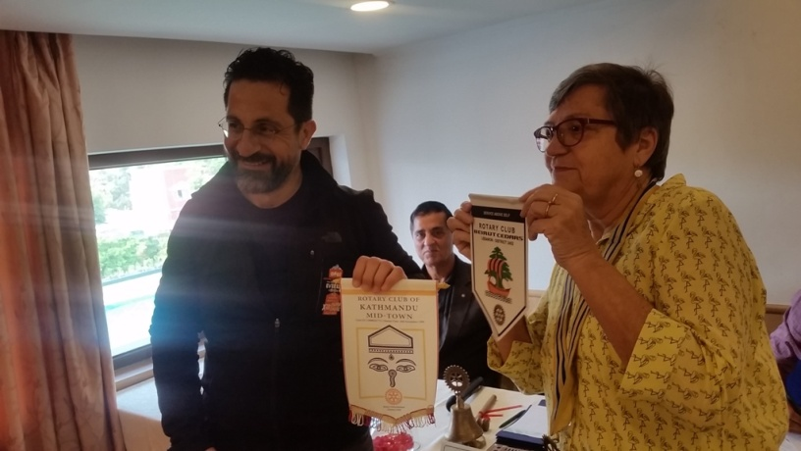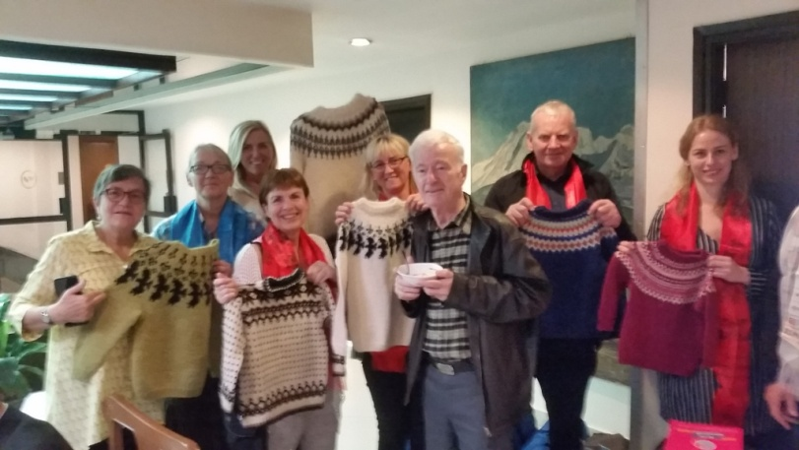

Exchanging club banners Mid-Towners in fellowship with visitors

*Photo courtesy: Dr Isabella Khadka*

**PHF Pin Handing over:**

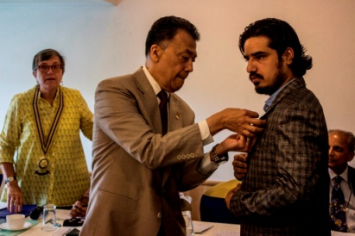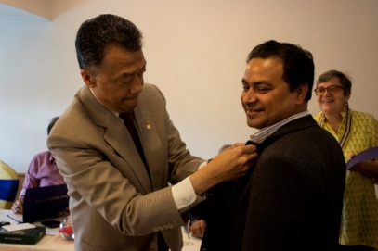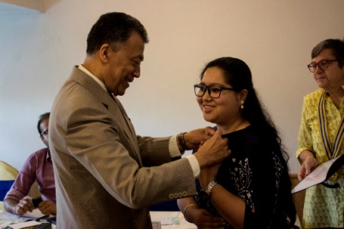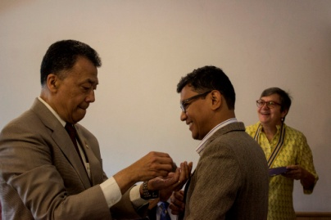

Charter President Dr Roop pinning Rotaractors with PHF pins

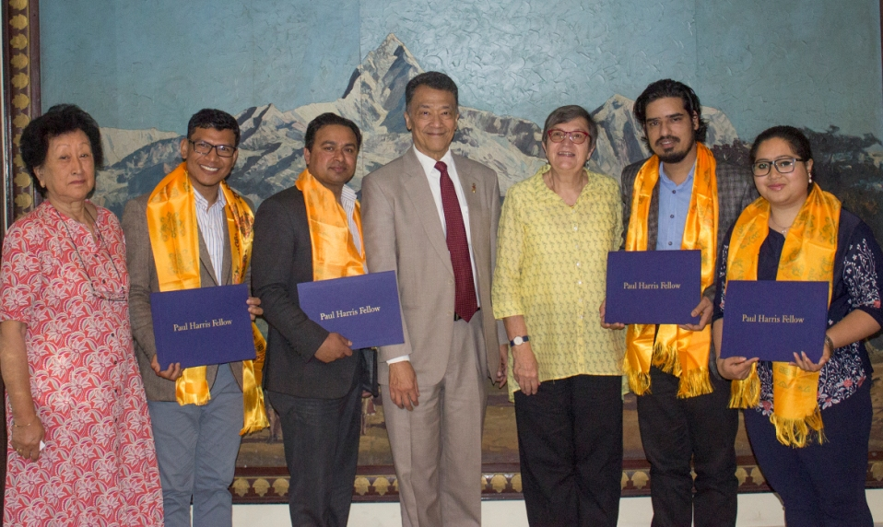

Charter President Roop, President Jo and Youth Service Chair Dr Chandra Lekha with Rotaractors

**Weekly Club Meeting # 1486 (19 April)**

Guest speaker Mr Sarosh Pradhan, a renowned Architect, talked about Spirit of design in Nepal.

A graduate from Delhi School of Planning & Architecture, Sarosh was the winner of the JK Foundations ‘Young Architect of the Year’ Award in Bangalore, in 2004. He is Editor in Chief of SPACES Nepalese Architectural, Art and Design journal.

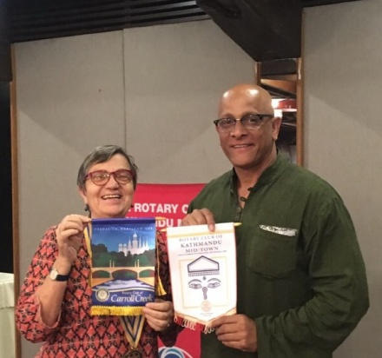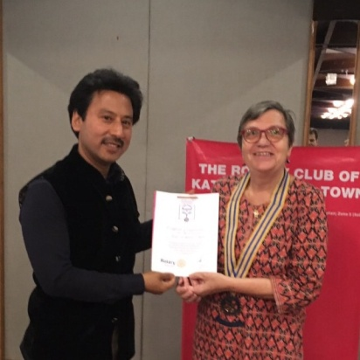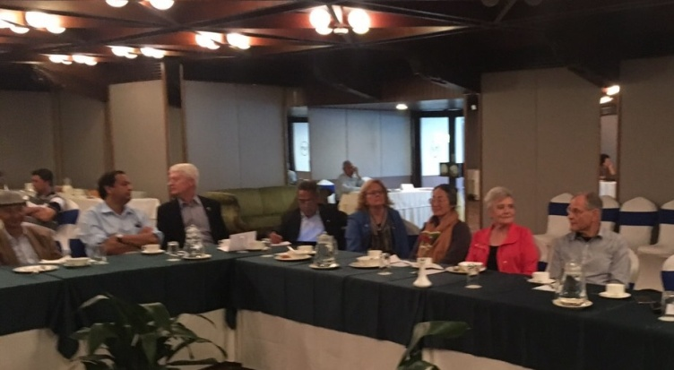

Echanging Club Banners Guest speaker with President Jo Club meeting on session

**Weekly Club Meeting # 1487 (26 April)**

Guest speaker will be Ms Shradha Ghale,

She will be talking about her Novel “The Wayward Daughter”, which is set in 1990s Kathmandu and tells the story of a middle-class family trying to navigate Nepal's socio-political realities.

**Grant Management Seminar:**

Grant Management Seminar is scheduled to be held on Sunday, 28 April, 2019. It is mandatory for all clubs to participate in this program to be eligible for undertaking District/ Global Grants in the Rotary Year 2019-2020. Club President and/ or TRF Chair or members actively involved in Service project/s are encouraged to attend this Seminar.

Date      : April 28, 2018, Sunday

Time  : 13:00 to 19:00 Hrs (followed by fellowship Dinner)

Venue  : Hotel Park Safari, Sauraha

Registration Fee : Rs 2,500 per registration

There are many good hotels in Sauraha. For hotel reservation assistance, please contact Bipin Pokhrel, President Elect, RC Ratnanagar, mobile: 9855056560, email:[pokhrelbipin81@gmail.com](mailto:pokhrelbipin81@gmail.com" \t "_blank)

**If You Like It**

A 30-Million-Page Archive of Human History Was Just Launched into Space.

In Feb 2019 a 30-million-page archive of human history and civilization launched aboard a spacecraft headed for the moon. The so-called "Lunar Library" is a small nanotech device that resembles a DVD, and it's intended as a "backup plan" so that everything we've ever learned as humans doesn't get lost in time, according to the nonprofit behind the idea, the [Arch Mission Foundation](https://www.archmission.org/spaceil).

The device is installed on Israel's Beresheet lander, which launched last week and is expected to touch down on the moon in April. Consisting of 25 nickel disks, each 40 microns thick, the archive is built to withstand space conditions. It holds a multitude of types of data explaining, well, humans.

The disks contain thousands of images of book pages, photos, illustrations, documents, the English Wikipedia, entire books, scientific handbooks, and a key that explains languages and translations between them. This library also contains songs, text and children's drawings relating to Israel's history and culture.

It's the third in a series of archives that make up the Billion Year Archive initiative. The project aims to put copies of this data in several places on Earth and in space so that the information is likelier to survive billions of years into the future.

The device contains both larger text that can easily be read with a simple magnifying glass and smaller text and photos that can be accessed only using more-powerful microscopes and technology.

*Read more on*  *https://www.livescience.com/64899-lunar-library-launched-to-moon.html*

**A THOUGHT FOR THE DAY**

**Speak to people the way you want a person speaks to you;**

**Treat people the way you want a person treats you;**

**Remember respect is earned when it is given.**

On Lighter Side:

A lawyer and a blonde are sitting next to each other on a long flight from LA to NY. The lawyer leans over to her and asks if she would like to play a fun game. The blonde is tired and just wants to take a nap, so she politely declines and rolls over to the window to catch a few winks. The lawyer persists, saying that the game is really easy and a lot of fun. He explains how the game works: "I ask you a question, and if you don't know the answer, you pay me, and visa-versa." Again, she politely declines and tries to get some sleep. The chauvinistic lawyer figures that since his opponent is a blonde he will easily win the match, so he makes another offer: "Okay, how about this, if you don't know the answer you pay me only $5, but if I don't know the answer, I will pay you $500."

This catches the blonde's attention and, figuring that there will be no end to this torment unless she plays, she agrees to play the game.

The lawyer asks the first question. "What's the distance from the earth to the moon?"

The blonde doesn't say a word, reaches in to her purse, pulls out a five-dollar bill, and hands it to the lawyer. Now, it's the blonde's turn. She asks the lawyer, "What goes up a hill with three legs, and comes down with four?"

The lawyer looks at her with a puzzled look. He takes out his laptop computer and searches all his references. He taps into the Airphone with his modem and searches the Net. Frustrated, he sends emails to all his co-workers and friends he knows. All to no avail. After over an hour, of searching for the answer he finally gives up. He wakes the blonde and hands her $500. The blonde politely takes the $500 and turns away to get back to sleep.

The lawyer, who is more than a little frustrated, wakes the blonde and asks, "Well, so what is the answer?"Without a word, the blonde reaches into her purse, hands the lawyer $5, and goes back to sleep!

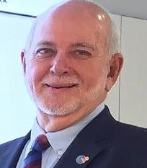

When Rotaractors are ready to leave their Rotaract club, we don't want them to leave that

Rotary family behind. I'm asking all Rotarians to help them make the transition into a

Rotary club or to start a new one: I'm happy to charter as many new clubs as we need to give

everyone a place where they feel at home while making the world a little better. Service

should be fun, it should be inspirational, and it should be open to all.

**RI President Barry Rassin**

Please send information on club activities, progress reviews on service projects, relevant photos etc to:

BC Editor: RR Shrestha email: rryesrr@gmail.com

## 26 April 2019 The Weekly Bulletin of Rotary Club of Kathmandu Mid-Town bc-27.4/019